LAB #5

MAMMALIAN SKELETON AND SKINS OF DIDELPHIMORPHIA, LAGOMORPHA, CHIROPTERA, AND REMAINING INSECTIVORA AND RODENTIA

The mammalian skeleton serves four primary functions: 1) support, 2) protection, 3) attachment sites for muscles, and 4) leverage for movement. Although similarities are found in skeletal morphology, shape, and structure between the various subgroups of mammals, many differences are noted as well. These modifications are adaptations to more recently evolved, specialized lifestyles. We will use the domestic cat skeleton as our model to learn the basic units of the skeleton. The mammalian skeleton can be subdivided into two main regions, the axial skeleton and appendicular skeleton. The axial skeleton is comprised of the vertebral column and ribs, whereas the appendicular skeleton consists of the appendages used for locomotion. Except for the cetaceans (whales) and sirenians (manatees and sea cows), mammals are tetrapods and have four appendicular limbs, although the limbs of the marine carnivores (seals, sea lions, and walruses), cetaceans (whales), and sirenians (manatees and sea cows) are highly modified. These modifications in the cetaceans and sirenians are so great that the hind limbs are vestigial and not externally visible.

AXIAL SKELETON

The axial skeleton is the primary source of support for the body and transfers this weight to the appendages. Additionally, by flexion and extension, the axial skeleton assists in movement. The vertebral column of the axial skeleton has five main regions: 1) cervical, 2) thoracic, 3) lumbar, 4) sacral, and 5) caudal. Examine the cat skeleton and locate these regions. Where is the axial skeleton the most flexible? Examine the different types of vertebrae on display. You should be able to identify each type of vertebrae (i.e., cervical, thoracic, lumbar, sacral, and caudal) when disarticulated.

APPENDICULAR SKELETON

The appendicular skeleton consists of the pelvic (hip) and pectoral (shoulder) girdles and their associated appendages. Modern terrestrial vertebrates, especially mammals, have greater locomotor capabilities because of the rotation of the appendages beneath the body. Use the diagrams on the following pages to learn the bones of the appendicular skeleton. The appendicular skeleton has been modified in the different groups of mammals for more specialized forms of locomotion. These changes are useful when comparing the different lifestyles exhibited by mammals. The most primitive form of locomotion is ambulatory (walking). The ambulatory mammals are plantigrade in form and few modifications are noted in the metacarpals and metatarsals as the animals walk on the soles of their feet. Plantigrade mammals may also run on their toes to lengthen their stride and thus increase speed. Examples of plantigrade locomotion include humans, apes, bears, and raccoons. A few of the plantigrades are truly cursorial (running) in locomotion; these are mice and shrews. The other cursorial mammals are either digitigrade or unguligrade. Animals are considered to be digitigrade when only the toes are in contact with the ground. Digitigrade mammals often exhibit a reduction in number of toes and the metacarpals and metatarsals are elongated. Mammals that rely on cursorial locomotion, either for feeding or predator avoidance, are often permanently digitigrade (e. g., Felidae and Canidae). Ultimate modification of the limb structure for cursorial movement is found in the ungulates, especially those inhabiting the open plains and grasslands. These animals are called unguligrade and the phalanges are elevated such that only the hooves contact the ground. Greatest reduction of digits is found in horses, which run on a single digit. Many other modes of locomotion are found in mammals. You should learn the following terms and be able to use them when describing the lifestyles of mammals.

TERMS USED TO DESCRIBE LOCOMOTION

Ambulatory -- walking (examples include: apes, bears, raccoons)
Amphibious -- spends time in both aquatic and terrestrial habitats (beaver, muskrat, otters)
Aquatic --living mostly in water, but can come onto land for some activities (seals)
Arboreal -- living in trees; may involve adaptations such as elongated limbs or a prehensile tail (New World monkeys)
Cursorial -- running (carnivores and ungulates)
Digitigrade -- running with only the digits touching the ground (carnivores)
Fossorial -- living underground, generally requires adaptations for digging tunnels or burrows in soil (moles, pocket gophers)
Glissant -- gliding (flying squirrels)
Graviportal -- walking on straight, pillar-like legs located directly beneath the generally heavy body (elephants, hippos)
Marine -- spending entire life in water, generally the ocean (whales)
Plantigrade -- walking or running on the soles of the feet (humans, raccoons)
Ricochetal -- jumping using only the hind legs for propulsion (kangaroos and kangaroo rats)
Saltatorial -- jumping using both the front and hind legs for propulsion (rabbits and hares)
Scansorial -- climbing (bears, squirrels, primates)
Unguligrade -- running with only the unguis or hooves touching the ground (ungulates)
Volant -- true flight (bats only)
CAT SKELETON

Use the skeletal material provided in lab to learn the following bones and structures of the cat skeleton.

1. Cranium 19. Pubis
2. Axis 20. Floating Rib
3. Cervical Vertebrae 21. True Rib
4. Thoracic Vertebrae 22. False Rib
5. Lumbar Vertebrae 23. Xiphoid Process
6. Sacrum 24. Sternebrae
7. Ilium 25. Manubrium
8. Ischium 26. Phalanges
9. Caudal Vertebrae 27. Metacarpals
10. Fibula 28. Carpals
11. Calcaneus 29. Ulna
12. Phalanges 30. Radius
13. Metatarsals 31. Humerus
14. Tarsals 32. Glenoid Fossa
15. Head of Femur 33. Spine
16. Femur 34. Scapula
17. Tibia 35. Atlas
18. Patella 36. Mandible

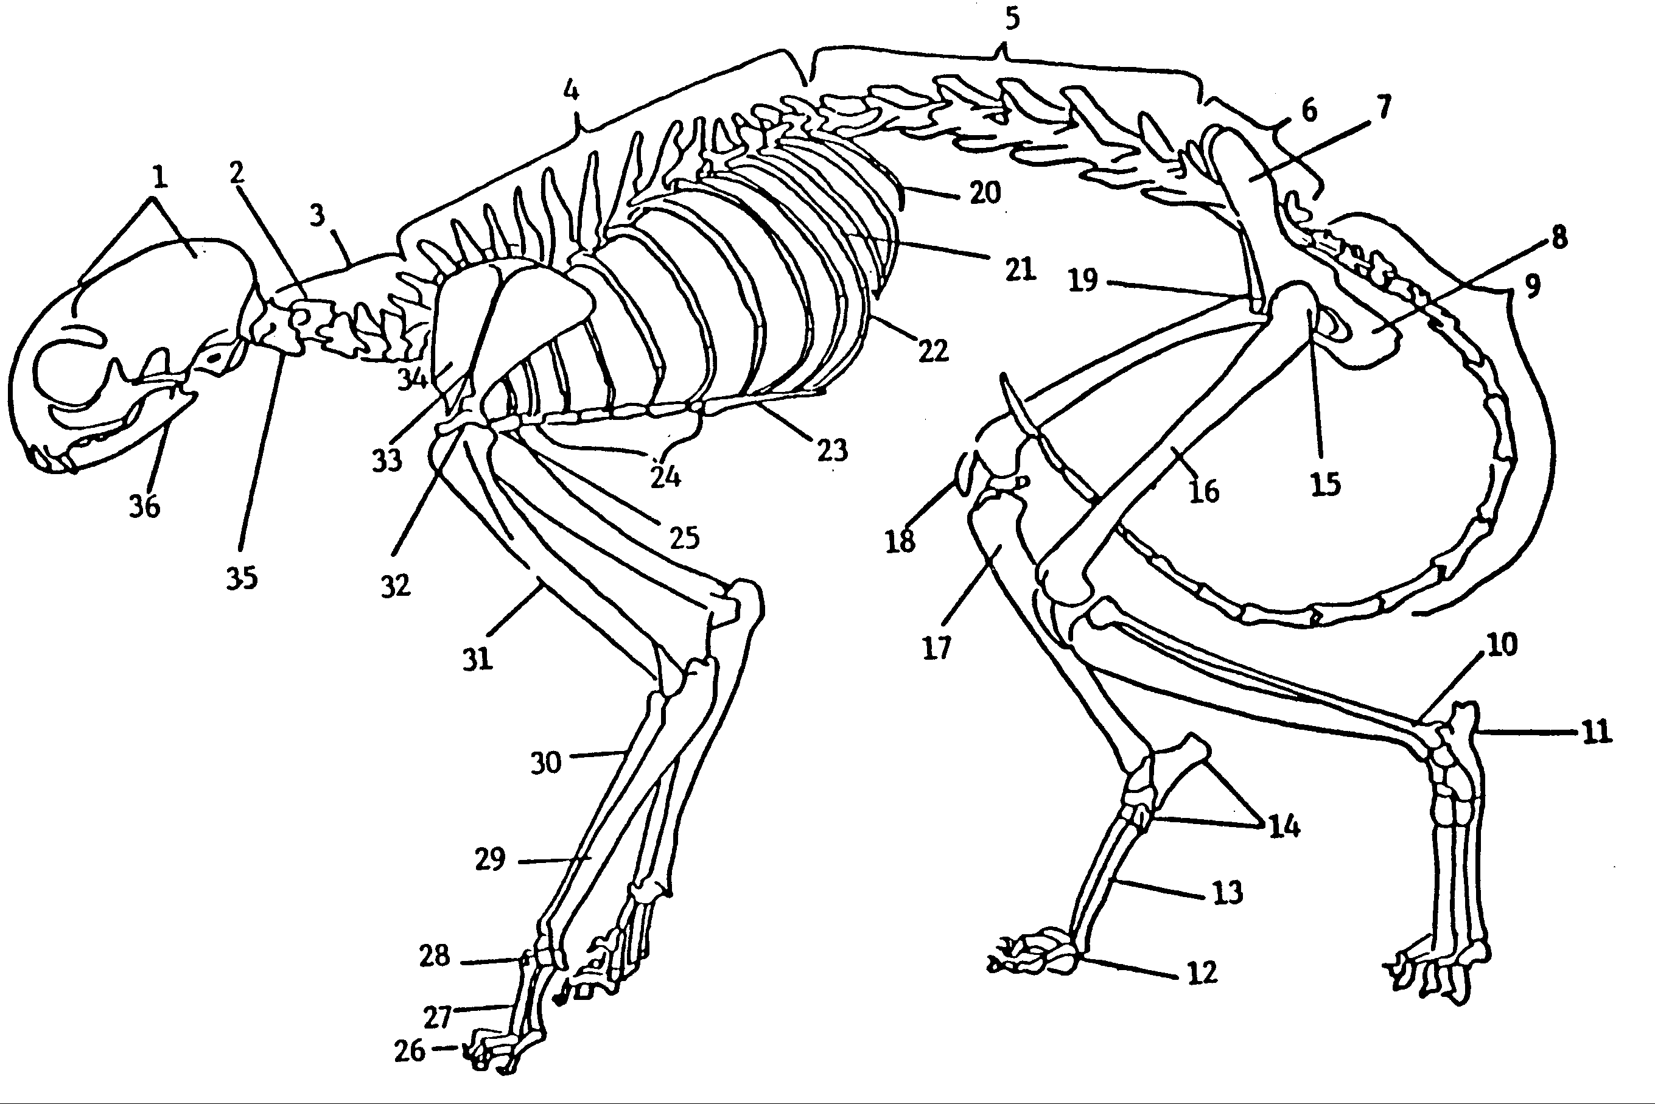

As you become familiar with the bones and structures, sketch and label the long bones, pelvic girdle, scapula, and vertebrae. Be sure to label any features that help you identify the different bones and vertebrae types. You will be expected to be able to identify a given vertebra to type (cervical, thoracic, lumber, sacrum, or caudal). Additionally, you may be asked to identify some of the more conspicuously shaped bones from the cat, even when they are disarticulated from the skeleton.

Scapula Forelimb

Pelvic girdle Hindlimb

1st cervical vertebra 2nd cervical vertebra Typical cervical vertebra

Thoracic vertebra Lumbar vertebra

Sacrum Caudal vertebra

TERMS CONCERNING THE MAMMALIAN SKELETON AND LOCOMOTION

ambulatory--ambul: walk
amphibious--amphi: on both sides; bio: life
appendicular--append: to hang
aquatic--aqua: water
arboreal--arbor: tree
atlas--atla: a giant bearing up the earth
axial--axi: an axle
axis--axi: an axle
calcaneus--calcan: heel
carpals--carp: wrist
caudal--caud: tail
caudal articular process--caud: tail; artic: a joint; process: projection
cervical--cervi: neck
cranial articular process--crani: the skull; artic: a joint; process: projection
cranium--crani: the skull
cursorial--curso: run or runner
dens--dens: dens, thick, compact
digitigrade--digiti: a finger or toe; grade: walk or step
femur--fem: high
fibula--fibul: a clasp, buckle or splint
fossorial--fossori: a digger
glenoid fossa--glen: a cavity or socket for a bone; oid: like; fossa: a ditch or trench
glissant--gliss: to glide
graviportal--gravi: heavy; port: to carry
hemal process--hem: blood; process: projection
humerus--humer: upper bone of arm
ilium--ile: the groin
ishium--ischi: the hip-joint
lumbar--lumb: the loin
mandible--mandib: jaw bone
manubrium--manubri: a handle
metacarpals--meta: after; carp: wrist
metatarsals--meta: after; tars: ankle
patella--patell: a little dish
pectoral--pector: breast
pelvic--pelv: basin
phalanges--phalang: a bone of the finger or toe
plantigrade--planti: sole of the foot; grade: walk or step
pubis--pubis: the region of the pubes or the pubic bone
radius--radi: a spoke
ricochetal--ricochet: bouncing off of
sacral--sacr: sacrum
sacrum--sacr: comes from sacral bone which was offered up in sacrifices to gods
saltatorial--saltator: a leaper
scansorial--scans: to climb
scapula--scapul: the shoulder blade
spinous process--spin: a spine; process: projection
sternebrae--stern: breast or chest; brae come from vertebrae
subunguligrade--sub: almost; unguli: nail or hoof; grade: walk or step
tarsals--tars: ankle
tetrapod--tetra: four; pod: foot
thoracic--thorac: breastplate
tibia--tibi: shin bone
transverse foramen--trans: across; vers: to turn, change; foram: an opening
transverse process--trans: across; vers: to turn, change; process: projection
ulna--ulna: the lower arm
unguligrade--unguli: nail or hoof; grade: walk or step
vertebrae--vertebr: a joint (vert: to turn)
volant--vol: to fly
xiphoid process--xiph: a sword; oid: like; process: projection

SUFFIXES:

-al--relating to
-ar--pertaining to
-ic--belonging to, relating to
-icular--denotes means of or instrument of
-oid--like
-ous--full of or possessing qualities of
-tory--agent or doer of an action
-us--condition of

SKINS OF DIDELPHIMORPHIA, LAGOMORPHA, CHIROPTERA, AND REMAINING INSECTIVORA AND RODENTIA

The goal for this lab is to learn to identify the skins of the mammals listed below. Consult the list of external features that vary among different species of mammals that was included in the lab on common insectivores and rodents. BEFORE you attend this lab, work on scientific and common names and some obvious features given in your field guide.

QUIZ AND EXAM

Didelphis virginiana
Eptesicus fuscus
Nycticeius humeralis
Scalopus aquaticus
Sylvilagus floridanus
Lepus californicus
Geomys bursarius
Glaucomys volans
Sciurus carolinensis
Perognathus sp.
Castor canadensis
Onychomys leucogaster
Ondatra zibethicus
Rattus norvegicus
Mus musculus
Erethizon dorsatum
Neotoma micropus

