LAB #2

MAMMALIAN SKULL

The mammalian skull is a complex structure that serves two primary functions: 1) protection of the brain and other sensory receptors and 2) attachment sites for jaw muscles. The general shape of a mammalian skull reflects its evolutionary history; however, the subsequent radiation of mammals from primitive forms to more specialized forms has caused numerous modifications. These changes, especially increased cranial capacity, are the result of heightened senses of smell, sight, and/or hearing in particular species of mammals. Various modifications make the skull one the most useful anatomical structure for classification and identification. These changes usually provide insight into the animal’s lifestyle. By the end of the course, you should be able to identify most mammals found in Texas by skull and dental characteristics, as well as recognize aspects of the lifestyles of mammals from these characteristics.

SKULL STRUCTURE

The skull is comprised of two main parts, the cranium and mandible (lower jaw). The cranium can be further subdivided into the braincase and rostrum. The braincase protects the brain; associated with it are the auditory bullae (plural; bulla is the singular form), foramen magnum, and occipital condyles. The foramen magnum is the opening for the spinal cord, and the occipital condyles articulate with the first cervical vertebrae (which is called the atlas). The rostrum projects forward from the anterior edge of the orbits (each encircles an eye) and includes the upper jaw, the bones that enclose the nasal passages, and the bones that separate the nasal passages from the oral cavity.

Although species-specific differences exist, many similarities can be found in mammalian skulls. In this exercise, you will compare the skulls of the coyote (Canis latrans) and beaver (Castor canadensis). You are responsible for being able to identify bones, regions, and structures of the skull listed on the subsequent pages and diagrams. You are expected to know definition listed in this lab (skull structures, teeth, etc.). Correct spelling also will be expected.

While learning the names of bones and regions of the skull, compare the skulls of the coyote and beaver. Keep in mind the differences in the natural history of each species. How do the sizes of the orbits, rostra, and auditory bullae differ between the coyote (a carnivore) and the beaver (a rodent)? Do these differences provide insight into the general food habits of these mammals?
DEFINITIONS FOR SKULL STRUCTURES

Foramen = opening in bone for a blood vessel or nerve (e.g., foramen magnum).

Process = projection of bone (e.g., postorbital process).

Condyle = knob-shaped bump on bone (e.g., occipital condyle).

Fossa = depression in bone for muscle attachment (e.g., temporal fossa).

Crest or ridge = elevated region (e.g., sagittal crest).

Orbit = area between zygomatic arch and cranium where eye rests (= eye socket).

Bullae = rounded, hollow, thin-walled structure (e.g., auditory bullae).

Fenestra = opening through bone (fenestrae = many openings; fenestrated = having many openings as in the skulls of rabbits).

Suture = junction between two contiguous bones of the skull.

Diastema = a vacant space, or gap, between teeth.

MAMMALIAN TEETH

Although mammalian teeth exhibit similar components, the number, size, shape, and structure of teeth vary widely among mammals. Part of these differences corresponds to differences in diet. Number, size, shape, and structure of teeth also serve as valuable tools in the classification and identification of mammals. Most mammals are diphoodont, that is, they have two sets of teeth. The deciduous or milk teeth are usually present in immature individuals and are later replaced by a set of permanent teeth. The toothed whales and a few other groups are monophodont (only one set of teeth).

The four basic types of teeth are incisor, canine, premolar, and molar. In many mammals, these teeth are heterodont, which means they differ in size and shape. Even so, it is impossible to distinguish premolars from molars in many adult mammals and the teeth are collectively called molariform teeth. Examine the skulls of the coyote and beaver. Can you find the four types of teeth? What types of teeth are missing from the beaver skull? The space between the incisors and the cheek teeth is a diastema. As you look at the skulls, keep in mind the general food habits of each species and consider how changes in tooth and skull morphology may better adapt each species for feeding and other uses of its teeth.
DEFINITIONS FOR TEETH

General types of teeth:
Incisor = typically a unicuspid (single cusp-point or projection on the surface of a tooth) tooth with a single root that is the most anterior of the tooth types. Upper incisors are rooted in the premaxilla; lower incisor as all other lower teeth are rooted in the dentary.

Canine = typically a unicuspid tooth with a single root. Canine teeth are posterior to the incisors. Upper canines are the most anterior teeth rooted in the maxilla.

Premolar = typically a multicuspid tooth. Premolars are posterior to the canine teeth and have deciduous predecessors (molars do not). Upper premolars are rooted in the maxilla.

Molar = typically a multicuspid tooth. Molars, posterior to premolars, do not have deciduous predecessors and are typically larger with more cusps than premolars.

Terms relating to crown (part of tooth visible above the gum) height:
Brachyodont = low-crowned cheek teeth with deep roots (e.g., humans, pigs, tapirs)

Hypsodont = high-crowned cheek teeth with short roots (e.g., horses, cattle, elephants)

Types of molar crown patterns:
Bunodont = crown pattern with low, cone-shaped or rounded cusps; crushing tooth for omnivorous diet (e.g., molars in pigs and humans)

Lophodont = crown pattern with tranverse cusps with intervening valleys; grinding tooth for herbivorous diet (e.g., elephants, tapir)

Selenodont = pattern of crescent-shaped longitudinal cusps; grinding tooth for herbivorous diet (e.g., deer, cattle)

Dilambdodont = W-shaped pattern of cusps (e.g., bats)

Other definitions:
Carnassial pair = shearing teeth found in Carnivora that consist of the last upper premolar and first lower molar (e.g., coyote)

Homodont = all teeth alike in shape (e.g., toothed whales)

Heterodont = teeth vary in shape and size (e.g., humans)

DENTAL FORMULAE

The dental formula describes the numbers of each kind of tooth in a specific sequence. The formula is divided in to two sections that correspond to the upper and lower teeth (above and below the line, respectively). The two sets of numbers represent the right and left side of the jaw. The complete dental formula for the Virginia opossum (Didelphis virginiana) is:

incisors 5 5 canines 1 1 premolars 3 3 molars 4 4 = 50
4 4 1 1 3 3 4 4

Since the two side of the jaw typically have identical numbers of teeth and the dental formula is always written in the standardized format, the dental formula is often abbreviated as:

5 1 3 4
4 1 3 4

Remember that each number must be multiplied by two to get the total number of teeth.

If a particular tooth is absent from a species, a 0 used. For example, the dental formula of the deer mouse is:

1 0 0 3
1 0 0 3

Look at the beaver and coyote skulls and see if you can determine the dental formula for each species. Although you will not be expected to memorize the dental formulae for mammals in Texas, familiarity with the number of teeth will be useful when trying to identify skulls. Lastly, you could be expected to determine the dental formula of one or two skulls on the laboratory exam.

FIGURE OF BONES, REGIONS, AND STRUCTURES OF THE COYOTE SKULL

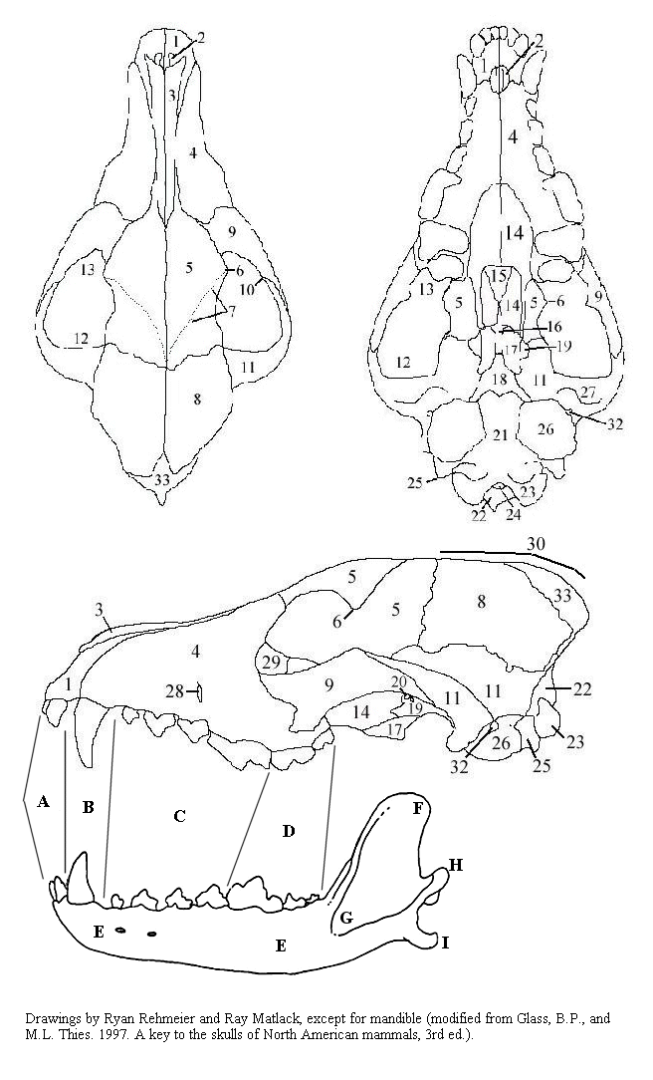

KEY TO BONES, REGIONS, AND STRUCTURES OF THE COYOTE SKULL

1. premaxilla 24. foramen magnum
2. palatal foramen 25. paroccipital process
3. nasal 26. auditory bulla
4. maxilla 27. mandibular fossa
5. frontal 28. infraorbital foramen
6. postorbital process 29. lacrimal bone
7. temporal ridge 30. sagittal crest
8. parietal 31. orbitosphenoid
9. jugal 32. external auditory meatus
10. zygomatic process of jugal 33. interparietal
11. squamosal
12. temporal fossa Teeth
13. orbit A. incisor
14. palatine B. canine
15. vomer C. premolar
16. presphenoid D. molar
17. pterygoid
18. basisphenoid Mandible
19. alisphenoid E. ramus
20. alisphenoid canal F. coronoid process
21. basioccipital G. masseteric fossa (coronoid fossa)
22. occipital H. mandibular condyle
23. occipital condyle I. angular process

FIGURE OF BONES, REGIONS, AND STRUCTURES OF THE BEAVER SKULL

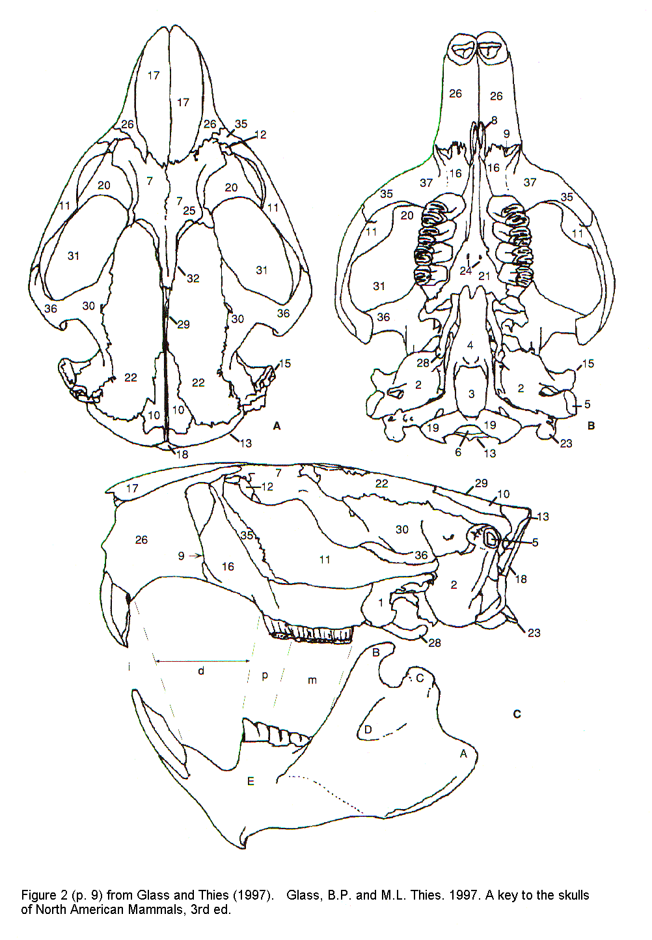
Key to bones, regions, and structures of the beaver skull
(Numbers correspond to labels on Fig. 2 in Glass and Thies, 1997)

Cranium
2 auditory bulla
5 external auditory meatus
6 foramen magnum
7 frontal
8 anterior palatal foramen
11 jugal
12 lacrimal
16 maxilla
17 nasal
18 occipital
19 occipital condyle
20 orbit
21 palatine
22 parietal
25 postorbital process
26 premaxilla
28 pterygoid
29 sagittal crest
30 squamosal
31 temporal fossa
32 temporal ridge

Mandible
A Angular process
B Coronoid process
C Mandibular condyle
D Masseteric fossa
E Ramus

Teeth
i Incisors
d Diastema (gap between incisors and premolars)
p Premolars
m Molars

A STUDY AID TO NAMES OF BONES, REGIONS, STRUCTURES, AND TEETH

alisphenoid--ali: wing; sphenoid: wedge-like
angular process--angul: having corners; process: projection
auditory bullae--audi: hearing; bull: a bubble
basioccipital--bas: base; occipit: back part of head
basisphenoid--bas: base; sphenoid: wedge-like
brachyodont--brachy: short; odont: tooth
bunodont--buno: a hill, mound; odont: tooth
canine--can: dog
carnassial--carnis: flesh
coronoid process--coron: crown; process: projection
diastema--diastema: an interval
dilambdodont--di: two; lambd: like Greek letter "lambda" (Λ); odont: tooth
diphyodont--diphy: of a double nature; odont: tooth
external auditory meatus--extern: outside; audi: hearing; meatus: a passage
foramen magnum--foramen: hole; magnum: great
frontal--front: forehead
heterodont--heter: different; odont: tooth
homodont--homo: alike; odont: tooth
hypsodont--hyps: high; odont: tooth
incisor--incis: to cut into; or: doer
infraorbital foramen: infra: below; orbit: circle; foramen: hole
jugal--jug: to join
lacrimal--lacrim: pertaining to tears
lophodont--lopho: a crest; odont: tooth
mandibular condyle--mandibul: to chew; condyle: knob-shaped bump
mandibular fossa--mandibul: to chew; fossa: depression
masseteric--masseter: a chewer
maxilla--maxilla: jaw
molar--mol: a millstone
monophydont--mono: one; phy: produce; odont: tooth
nasal--nas: nose
occipital--occipit: back part of head
occipital condyle--occipit: back part of head; condyle: knob-shaped bump
orbit--orbit: circle
orbitosphenoid--orbit: circle; sphenoid: wedge-like
palatal foramen--palat: roof of mouth; foramen: hole
palatine--palat: roof of mouth
parietal--parie: a wall
paroccipital process--par: beside or near; occipit: back part of head; process: projection
postorbital process--post: after, behind; orbit: circle; process: projection
premaxilla--pre: before or in front of; maxilla: jaw
premolar--pre: before or in front of; mol: a millstone
presphenoid--pre: before or in front of; sphenoid: wedge-like
pterygoid--pteryg: wing; oid: like
ramus--ram: branch
rostrum--rostrum: snout
sagittal crest--sagitt: arrow; crest: plume on head
selenodont--selen: the moon; odont: tooth
squamosal--squam: a scale
temporal fossa--tempor: the temples; fossa: depression
temporal ridge--tempor: the temples
vomer--vomer: a plowshare
zygomatic process of the squamosal--zyg: joining; process: projection

SUFFIXES:

-al--relating to
-ar--pertaining to
-ine--pertaining to
-odont--tooth
-oid--like
-tory--agent or doer of action
-us--condition of

TYPES OF TRAPS

Live Traps

Live traps or box traps are a much used tool by mammalogists and wildlife biologists. The advantage of using a live trap is that animals can be captured and brought back to the laboratory to be studied, transplanted to a new area or marked and released at the study site. Live traps come in various sizes and are made of various materials (e.g., aluminum, wire, wood). Several types of live traps are on display including Sherman folding and non-folding traps, drop-door trap, and homemade gopher live traps.

Pitfall Traps

Pitfall traps are made by digging a hole in the ground and then placing tin cans or jars in the hole such that the lip or rim of the container is flush with the soil surface. This trap is especially effective on shrews and other very small mammals, which are often not readily captured by live traps. Pitfall traps must be checked daily when in use. In some cases, food may be used to attract animals as well as to prevent starvation over night. This is especially true for shrews. When not in use, permanent pitfall traps must be capped or filled to prevent accidental deaths. The efficiency of these traps may be increased by adding drift fences (made of aluminum, hail screen, etc.) running between two or more pitfalls. An active animal encounters the drift fence, travels along the base of the fence, and eventually falls into the trap at the end of the fence.

Leghold Traps

Leghold traps or steel traps are used primarily by trappers to obtain the fur or for animal damage control and sometimes for scientific collecting. These traps catch mammals by one leg and have been the focus of concern relative to their damage to the trapped animal. In recent years leghold traps have been modified to reduce injury to captured animals. Modifications include padded and offset jaws (jaws do not close completely), repositioning of the trap chain, and addition of springs to reduce the impact incurred by a captured animal pulling on the chain. Steel traps come in various sizes with the smallest number code designating the smallest traps. They are also classified by their mode of action and the type of springs used. Examples of steel traps on display include long spring trap, jump trap, and coil spring trap. Below is a list of sizes used on various mammals.

Size 0: muskrat, prairie dog, tree squirrel, weasel, mink
1: muskrat, nutria, porcupine, prairie dog, tree squirrel, opossum, skunk, weasel, mink, domestic cat
2: marmot, muskrat, nutria, porcupine, prairie dog, tree, squirrel, badger, fox, raccoon
3: beaver, porcupine, badger, bobcat, coyote, dog, wolf, fox, raccoon
4: beaver, badger, bobcat, coyote, dog, wolf

Snares

Many styles of snares made of wire, cable, or cord have been constructed to capture a variety of intermediate- to large-sized mammals. Snares used by fur trappers are designed to kill the captured animal. In fact snares are often used by poachers to catch and kill mammals up to the size of elephants. More recently, modifications have been developed to prevent the snare from closing tightly around the captured animal. These modified snares are now occasionally used by ecological and behavioral scientists to capture mammals not effectively caught by other methods.

Body Gripping Traps

Body gripping traps are used primarily by trappers and sometimes for scientific collecting. The Conibear trap, manufactured in three sizes, is probably the best known body gripping trap. This trap kills the captured animal quickly and thus is more humane than the foothold traps. Other body gripping traps include the Macabee trap for pocket gophers and the harpoon trap for moles. These two traps (Macabee and harpoon traps) must be set in the animal's burrow.

Snap Traps

Snap traps are used by non-scientists to control rodents and can be used by scientists for collection of biological specimens. Snap traps come in three sizes and range in size from large (rat trap) to small (mouse trap). The Museum Special (the third size) is the snap trap used for scientific collection because it is slightly larger than a mouse trap and less powerful than the rat trap. The kill bar of the Museum Special is positioned so that it hits the small mammal across the back leaving the skull intact for scientific study. Rat traps can effectively be used on woodrats, chipmunks, ground squirrels, and similarly-sized mammals, whereas a mouse trap should be used to catch smaller mammals.

Camera Traps

A number of manufacturers produce cameras that are designed to be placed in the field to capture photographs of animals. Most of these cameras are designed as game cameras and are marketed to hunters. Biologists quickly learned that these systems could be useful in wildlife studies and these cameras have been used in many studies including monitoring use of underpasses by Florida panthers. Camera traps use some type of triggering device (generally an infrared beam between two units or simple motion detector) to detect the presence of an animal and capture a picture on film or in a digital format. Film cameras tend to be less expensive but development costs are high and results are not immediately available. Digital systems are more expensive (prices are dropping all the time) but pictures are stored on a memory card or on internal storage so development costs are eliminated. Additionally, many digital cameras allow you to select for a photograph(s) or short video clip to be recorded when motion is detected. Both types of camera systems can be tricky to use and require some time and practice before users become proficient. Keep in mind that these systems are hard on batteries and the cost of batteries alone can make use of a large number of cameras prohibitively expensive. New options are available in these systems including infrared flash or illumination (the light is not visible to humans and many animals) and more options can be expected in the future. Currently, these cameras can be purchased for $50 to well over $1,000 depending on the manufacturer and type of system. Video systems using mini dv camcorders or other video recorders are available but are much more expensive.

